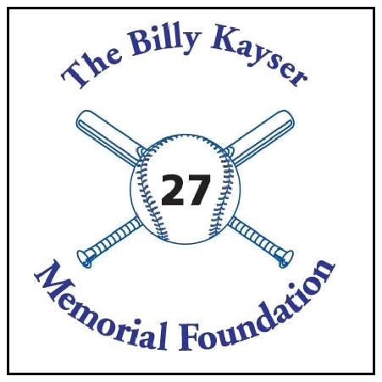
The Billy Kayser
Memorial Foundation

17th Annual Golf Tournament
Monday, September 30, 2019 -- Rockland Country Club

REGISTRATION FORM

Proceeds will go towards student scholarships at Pearl River High School and

St. Margaret School, and donations in the form of equipment, such as scoreboards, so that all the local children will benefit.

WHEN: Monday, September 30, 2019 ● Sign In: 8:30am ● Tee off: 10:00 am

WHERE: Rockland Country Club ● 380 Route 9W ● Sparkill, NY 10976

COST: Tax-Deductible Donation: $200 per golfer
__________________________________________________________________

CONTINENTAL BREAKFAST ● BUFFET LUNCH ● RAFFLES & PRIZES

NAME | PHONE | ADDRESS

Foursome Contact Name:_____________________________Phone:______________

Address:______________________________________________________________

Email Address:_____________________________________________________

- Cash or

- Check made payable & mail to:

The Billy Kayser Memorial Foundation
32 Sickletown Road
Pearl River, NY 10965

For More Information:

Call: Tom Clifford 845-359-3060 or Rob Fair 845-365-1350
Fax: 845-735-4345

Web: www.billykayser.com/golfouting.html Email: tcliff33@optonline.net

The Billy Kayser Memorial Foundation is a 501(C)3 exempt organization

