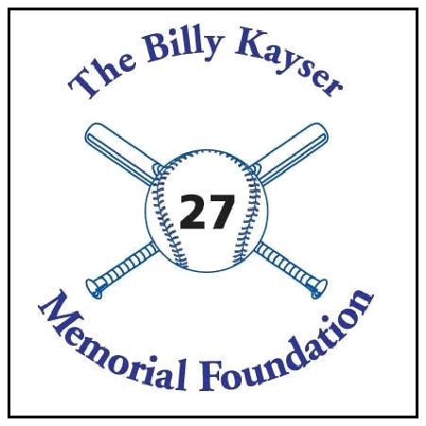
The Billy Kayser
Memorial Foundation

17th Annual Golf Tournament
Monday, September 30, 2019 -- Rockland Country Club

SPONSORSHIP FORM

Proceeds will go towards student scholarships at Pearl River High School and

St. Margaret School, and donations in the form of equipment, such as scoreboards, so that all the local children will benefit.

□ Elite Sponsor ($1,500):

Limited to five sponsors at this level, this sponsorship entitles you to one foursome in the outing, on-course signage, luncheon signage, and prominent mention during luncheon remarks.

□ Major Sponsor ($1,000):

Limited to ten sponsors at this level, this sponsorship entitles you to two golfers in the outing, luncheon signage, and recognition during luncheon remarks

□ Foursome & Tee Sponsor ($750):

This sponsorship entitles you to tee signage on one hole, prominent recognition during the luncheon remarks, and sponsors four golfers from Billy’s high school to play in the outing in your name.

□ Flag Sponsor ($150):
This sponsorship entitles you to on-course signage and recognition during luncheon remarks.

□ I am not able to sponsor, but would like to donate $____________ to The Billy Kayser Memorial Foundation.

Contact Name:______________________________________________________________

Business Name:_____________________________________________________________

Street Address:______________________________________________________________

City, State, Zip______________________________________________________________

Email Address:_____________________________________________________________

□ | Check enclosed in the amount of $__________ or □ Cash $__________
 |  | For More Information:
Make Checks payable & mail to: |  | For More Information:
 |  | Call: Tom Clifford @ 845-359-3060 or
The Billy Kayser Memorial Foundation |  | Rob Fair @ 845-365-1350
32 Sickletown Road |  | Fax: 845-735-4345
Pearl River, NY 10965 |  | Email: tcliff33@optonline.net

The Billy Kayser Memorial Foundation is a 501(C)3 exempt organization

