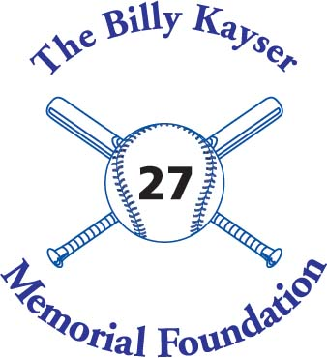

Billy Kayser Memorial Scholarship

Attach this cover sheet to your essay and submit it to the Guidance Office by April 12, 2024. On the actual essay the only identifying information should be your birth date and the last 4 digit’s of your social security number. This is to keep the essays anonymous.

Name ____________________________________________________

Address__________________________________________________
_________________________________________________________
_________________________________________________________

Email Address_____________________________________________

Phone ___________________________________________________

Birth date_________________________________________________

Last 4 digits of social security #_______________________________

